Sales Dashboard Analysis using Power BI

Introduction
This project is developed using Power BI to analyze and visualize sales data. The dashboard provides a comprehensive view of business performance by displaying important metrics such as Total Sales, Total Profit, Total Quantity Sold, and Total Orders. It helps users understand sales performance across different product categories, regions, and months.
The dashboard also includes visualizations for payment mode distribution and top-selling products, making it easier to identify customer preferences and business trends. Interactive charts and filters allow users to explore data efficiently and gain meaningful insights.
The main goal of this project is to transform raw sales data into clear and interactive visual reports that support better business analysis and decision-making. By using Power BI, the dashboard presents information in a simple, organized, and user-friendly manner.
Objectives
• To analyze overall sales performance using Power BI.
• To identify top-selling products and categories.
• To compare sales performance across different regions.
• To analyze monthly sales trends and patterns.
• To provide meaningful insights for better business decision-making.

Tools Used
- Power BI
- Power Query Editor
- Microsoft Excel
- DAX (Data Analysis Expressions)

Dataset Description
The dataset contains sales-related information, including product categories, product names, sales amounts, quantities sold, regions, order dates, and payment modes. This data is used to analyze sales performance, identify trends, and generate meaningful business insights through interactive Power BI visualizations.
• Product Category
• Product Name
• Region
• Sales Amount
• Quantity Sold
• Order Details
• Payment Mode
• Order Date

Data Preparation
- Imported dataset into Power BI.
- Cleaned and transformed the data.
- Removed duplicate records.
- Checked for missing values.
- Formatted data types.
- Developed DAX measures for calculations.
- Created visualizations and KPI cards.
Dashboard Components
KPI Cards :-
- Total Sales: 77M
- Total Profit: 12M
- Total Quantity: 16K
- Total Orders: 3K
Visualizations :-
- Total Sales by Category
- Total Sales by Region
- Total Sales by Month
- Payment Mode Distribution
- Top 5 Products Analysis
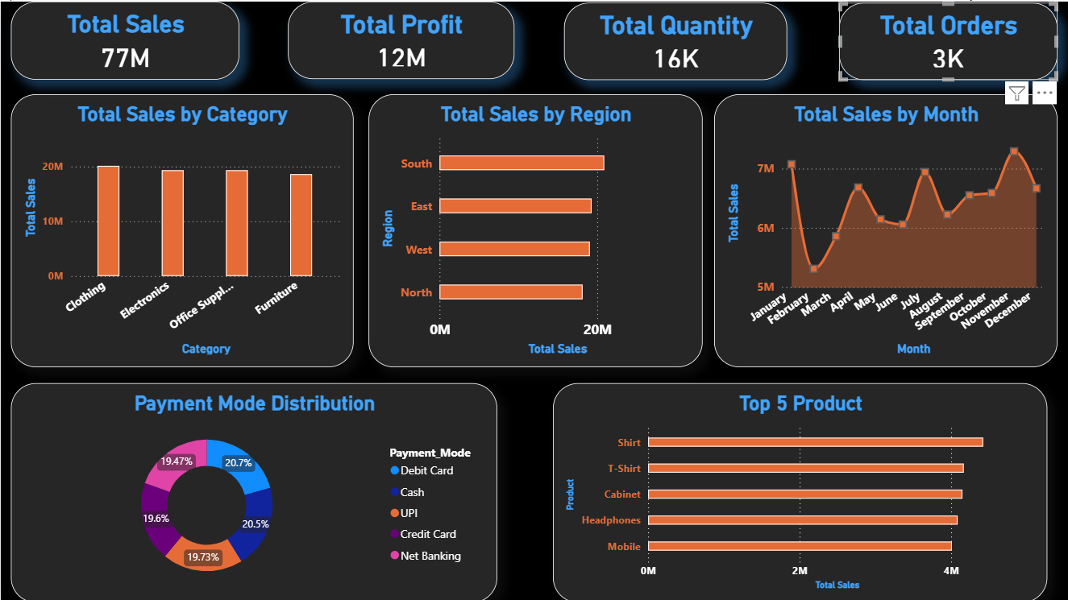

Key Insights
- Clothing category generated the highest sales.
- The South region recorded the highest sales performance.
- Sales peaked during November.
- Debit Card and Cash were among the most used payment methods.
- Shirt was the top-selling product.
Benefits of the Dashboard
• Easy monitoring of business performance.
• Quick identification of sales trends.
• Better understanding of regional sales.
• Supports data-driven decision-making.
• Interactive and user-friendly interface.

Challenges Faced

• Cleaning and preparing data.
• Creating accurate DAX measures.
• Designing effective visualizations.
• Selecting the right charts to represent data clearly.
• Ensuring dashboard accuracy and consistency.

Future Scope

• Real-time data integration.
• Sales forecasting and prediction.
• Advanced customer analysis.
• Integration with SQL databases.
• More detailed business reports.

Conclusion
The Sales Dashboard successfully provides a comprehensive view of sales performance through interactive visualizations. It helps businesses analyze sales trends, monitor key metrics such as total sales, profit, quantity, and orders, and identify top-performing products and categories. The dashboard also enables users to compare sales performance across different regions and understand customer payment preferences.
By transforming raw sales data into meaningful insights, the dashboard makes data analysis simpler and more efficient. The use of KPI cards, charts, and filters allows users to explore data easily and make informed business decisions. Overall, this project demonstrates how Power BI can be used to create effective and user-friendly dashboards for business analysis and reporting.

